**Preparing and Replenishing Odor Bottles Checklist**

How to make odor bottles

* Ensure that all supplies are in place in case we need to replace bottles!
  + Caps - Western Analytical Products Inc (Catalog Number: S32X-3D)
  + Bottles - Western Analytical Products Inc (Catalog Number: BT32-0050)
  + Plugs - Western Analytical Products Inc (Catalog Number: PL-104X)
  + Teflon nuts - Western Analytical Products Inc (Catalog Number: P-245)
  + Ferrules - Western Analytical Products Inc (Catalog Number: P-200X)
  + Tubing PTFE 1/32” – Cole Parmer (Catalog Number: 06407-41)
  + ¼-28 Female to Male Luer Red – Western Analytical (Catalog Number: P-675)
  + ¼-28 Female to Female Luer – Western Analytical Products (Catalog Number: P-678)
  + Filter – Whatman (Millipore Sigma Catalog Number: WHA68231327)
* Use gloves when working with all materials to keep them clean and odor-free
* Place necessary materials into a large plastic weigh boat for easy access, but do not reach into stock bags with your hands, just pour out what you need into the weigh boat
  + 1 bottle cap
  + 1 plug
  + 1 female luer
  + 1 male luer
  + “IN” long tubing, and “OUT” short tubing
  + 4 blue ferrule
  + 4 clear nuts

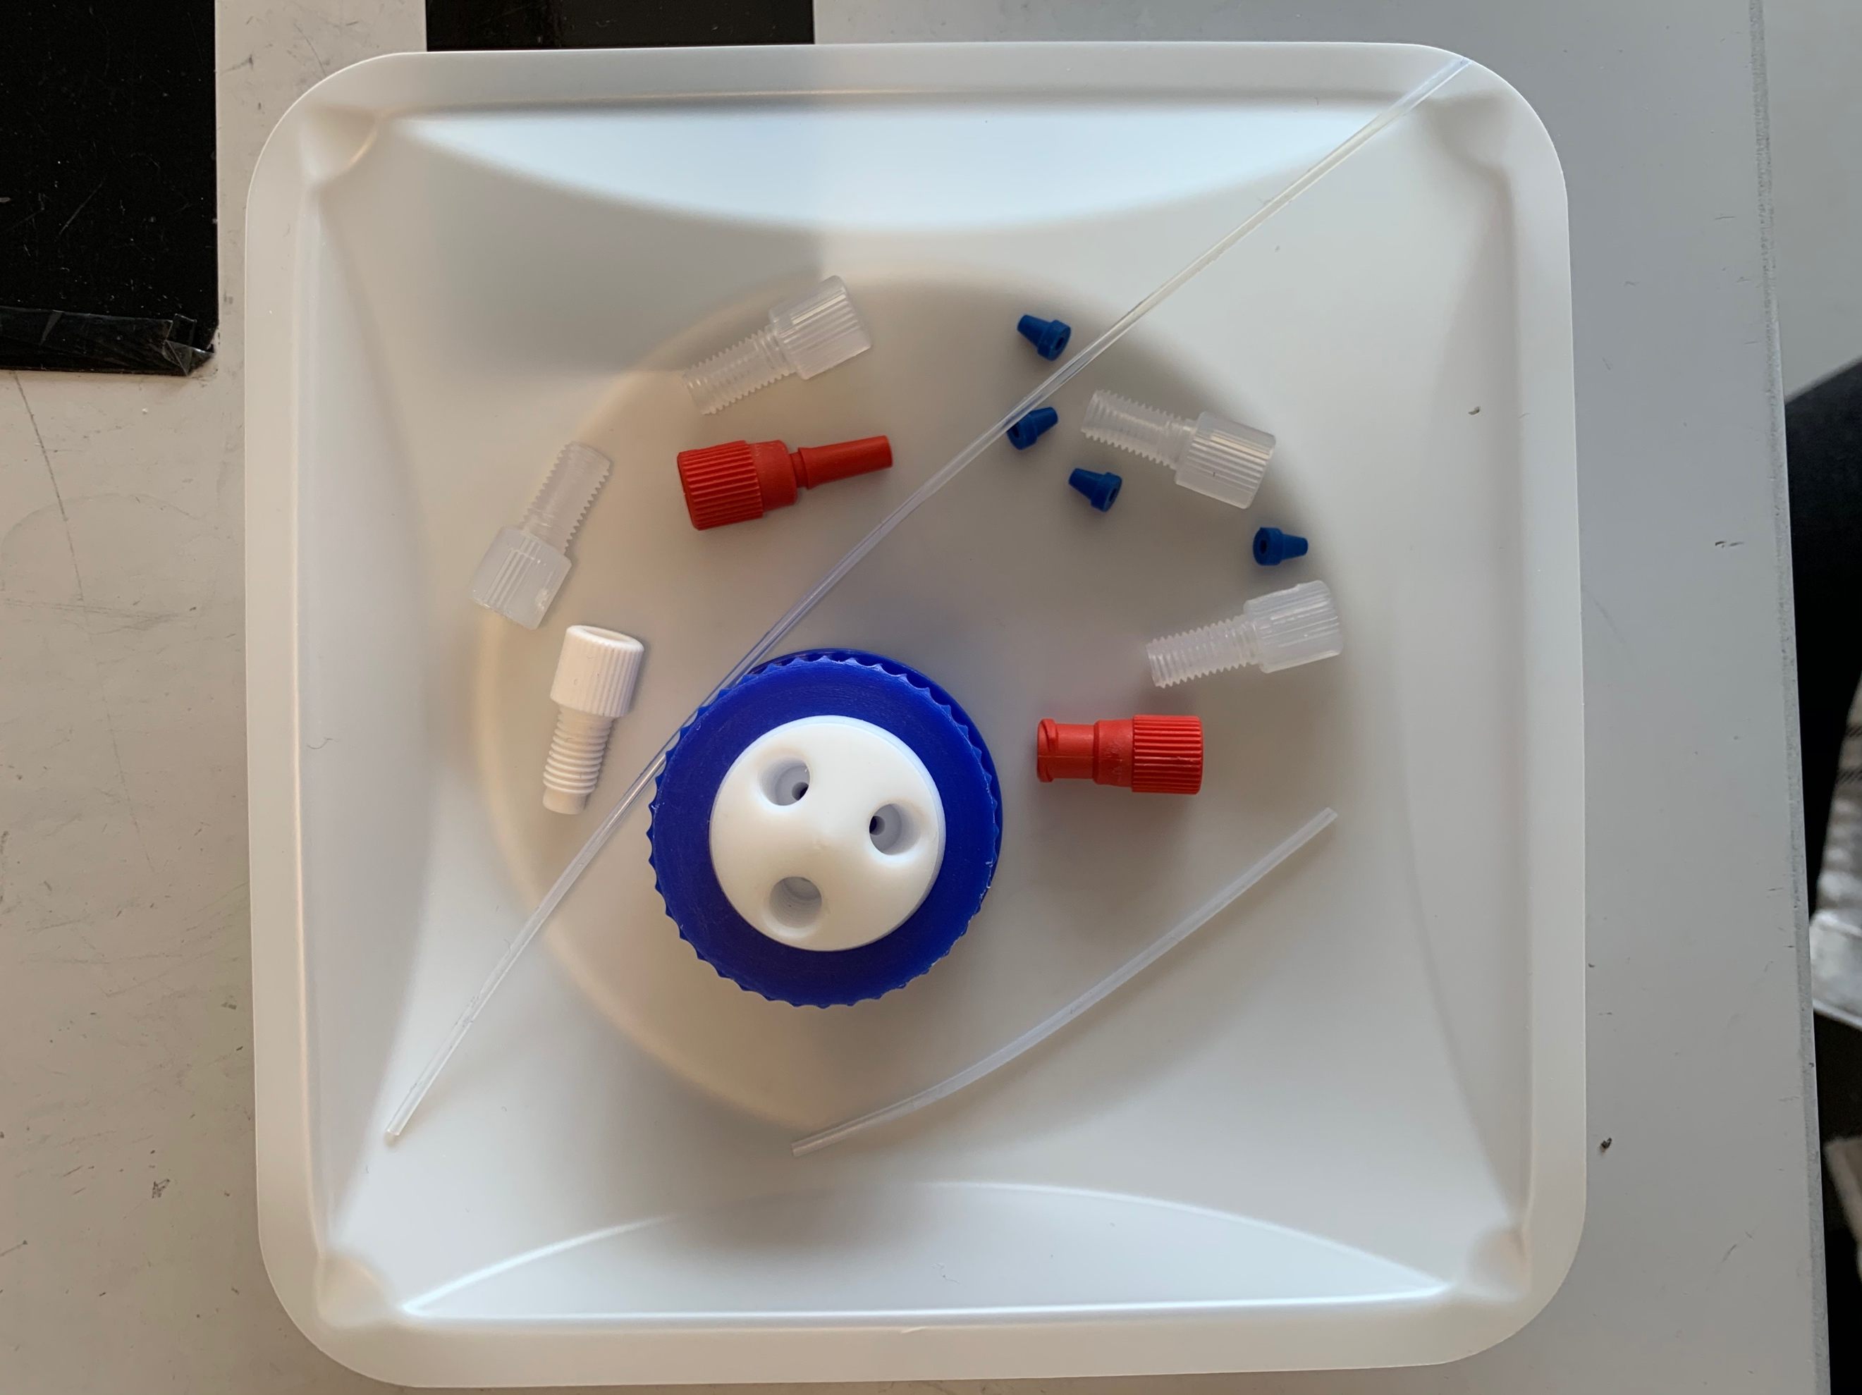

* Locate the “Odour Bottle Guide 12.22.23” sheet
  + This sheet helps you cut the tubing to the appropriate size. If you don’t have it…
    - 87mm for “IN” tubing
    - 78mm for “OUT” tubing
  + Cut one end of the “IN” tubing with the blue tube cutter so it makes a nice 90 degrees, and a bit longer than the guide suggests (so you have room to trim off some)
  + Take the other end of the tubing and use the blue tubing cutter to trim it to the right length
    - Measure the too-long tubing against the diagram, lining up the diagonally cut end with the diagram, and using your index finger and thumb to indicate the desired length on the other side
    - Without changing your grip on the tubing, place the straight end of the tubing into the tube cutter until your fingers are against the cutter
    - Cut the tubing, while holding it firmly so that you get a nice 90 degree cut
    - Now insert the same end back into the cutter until you can just barely see the tubing about to come out on the other side of the cutter, and cut it again
    - The tubing should now be the desired length. Ensure that it is by comparing it to the diagram

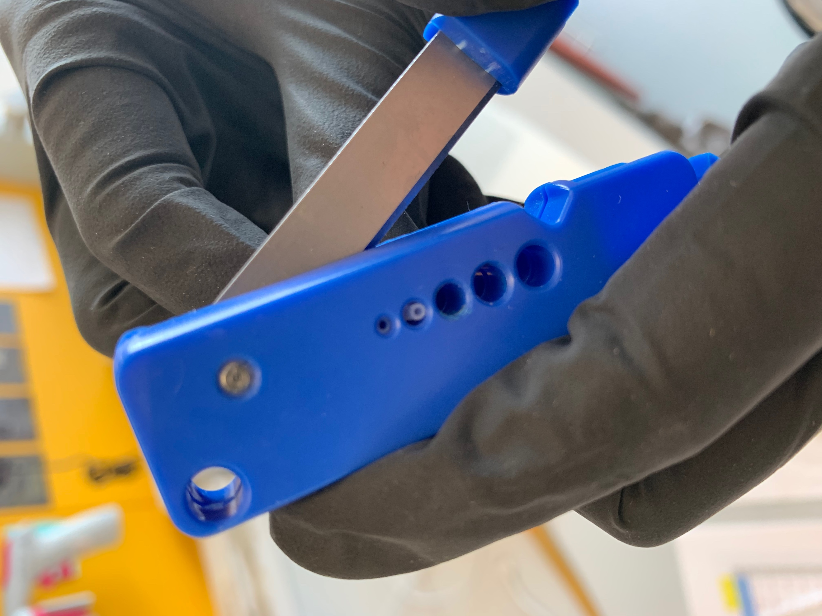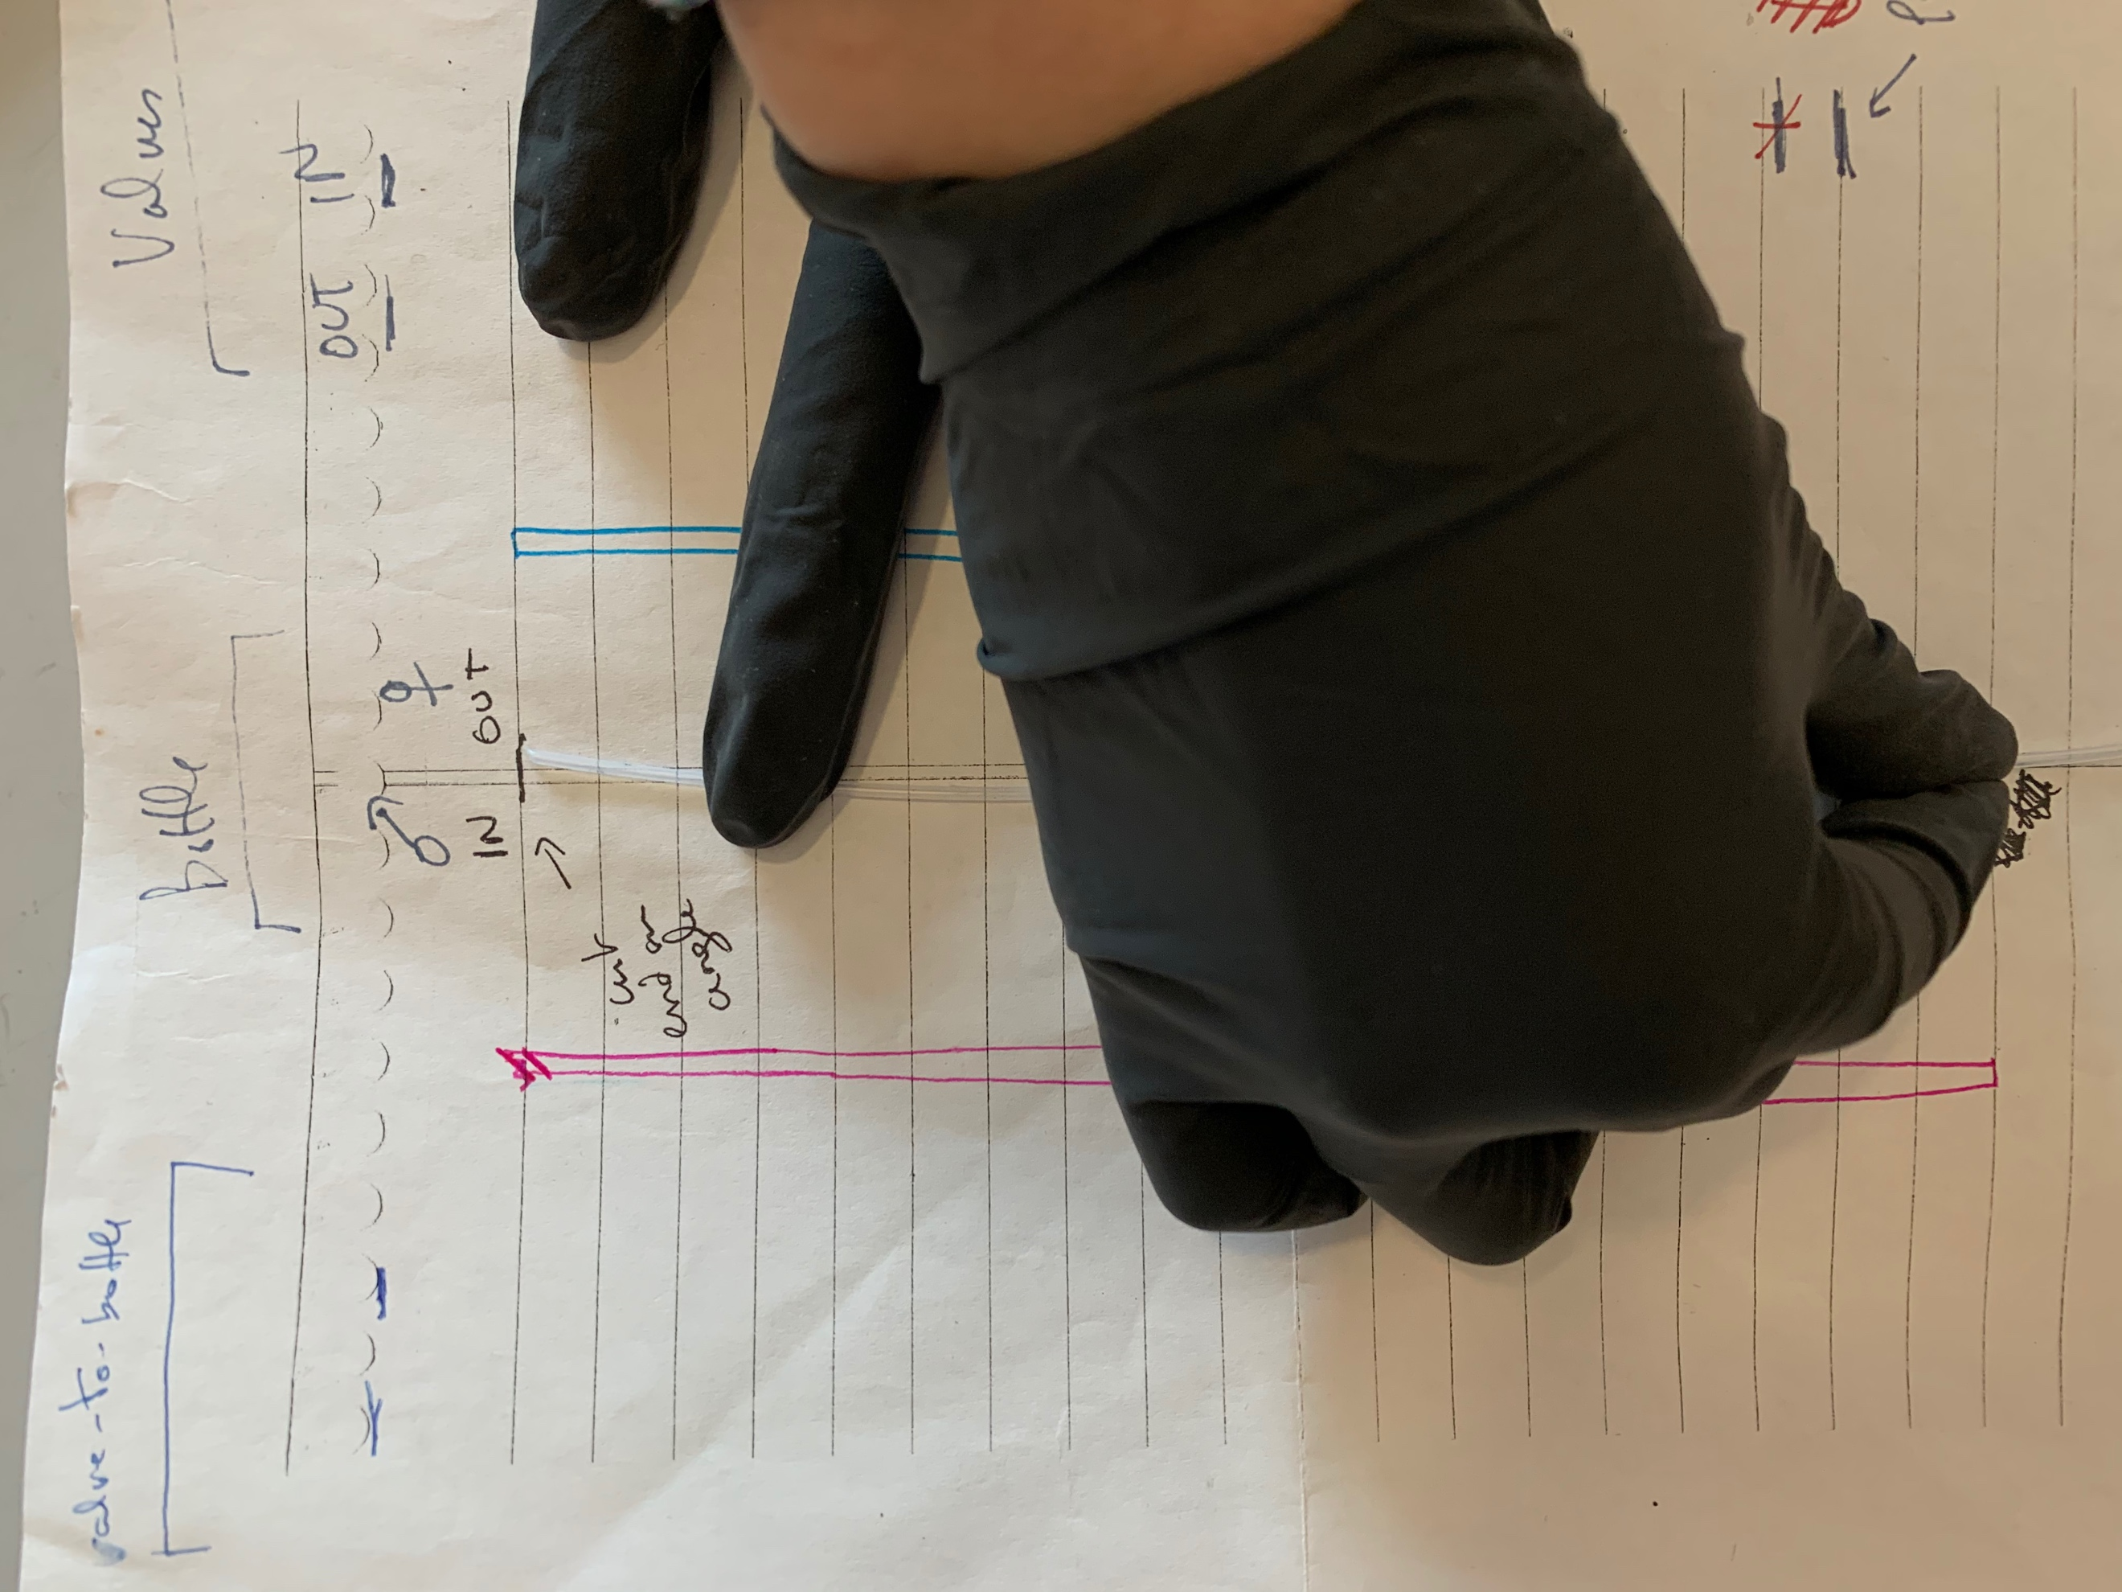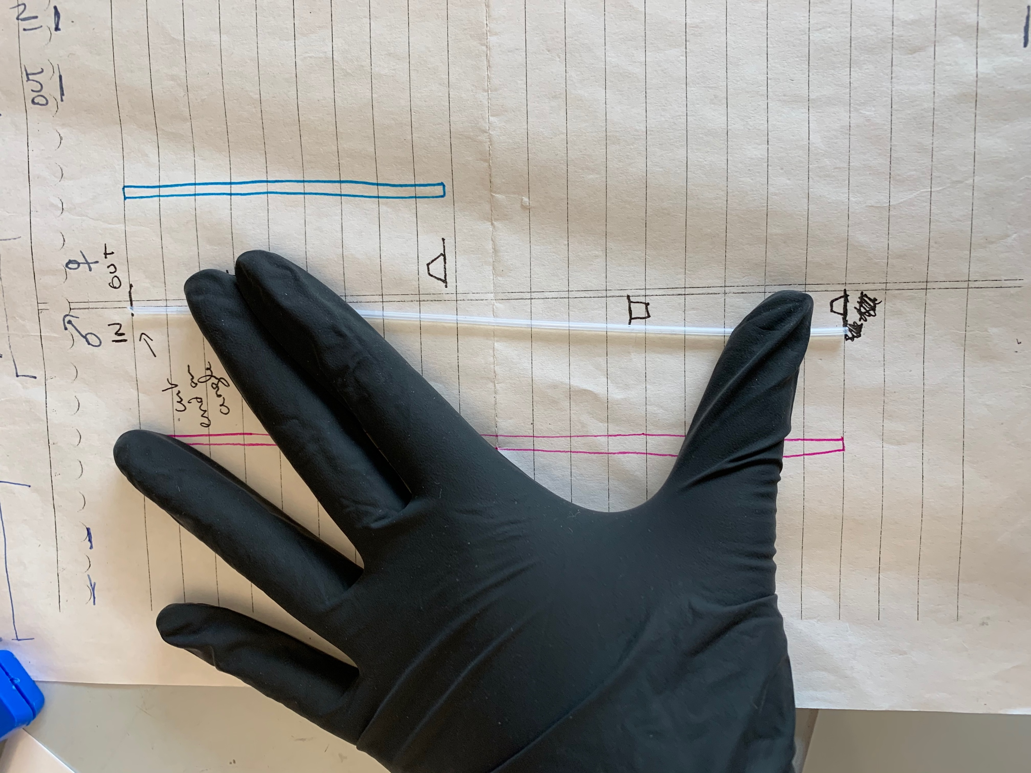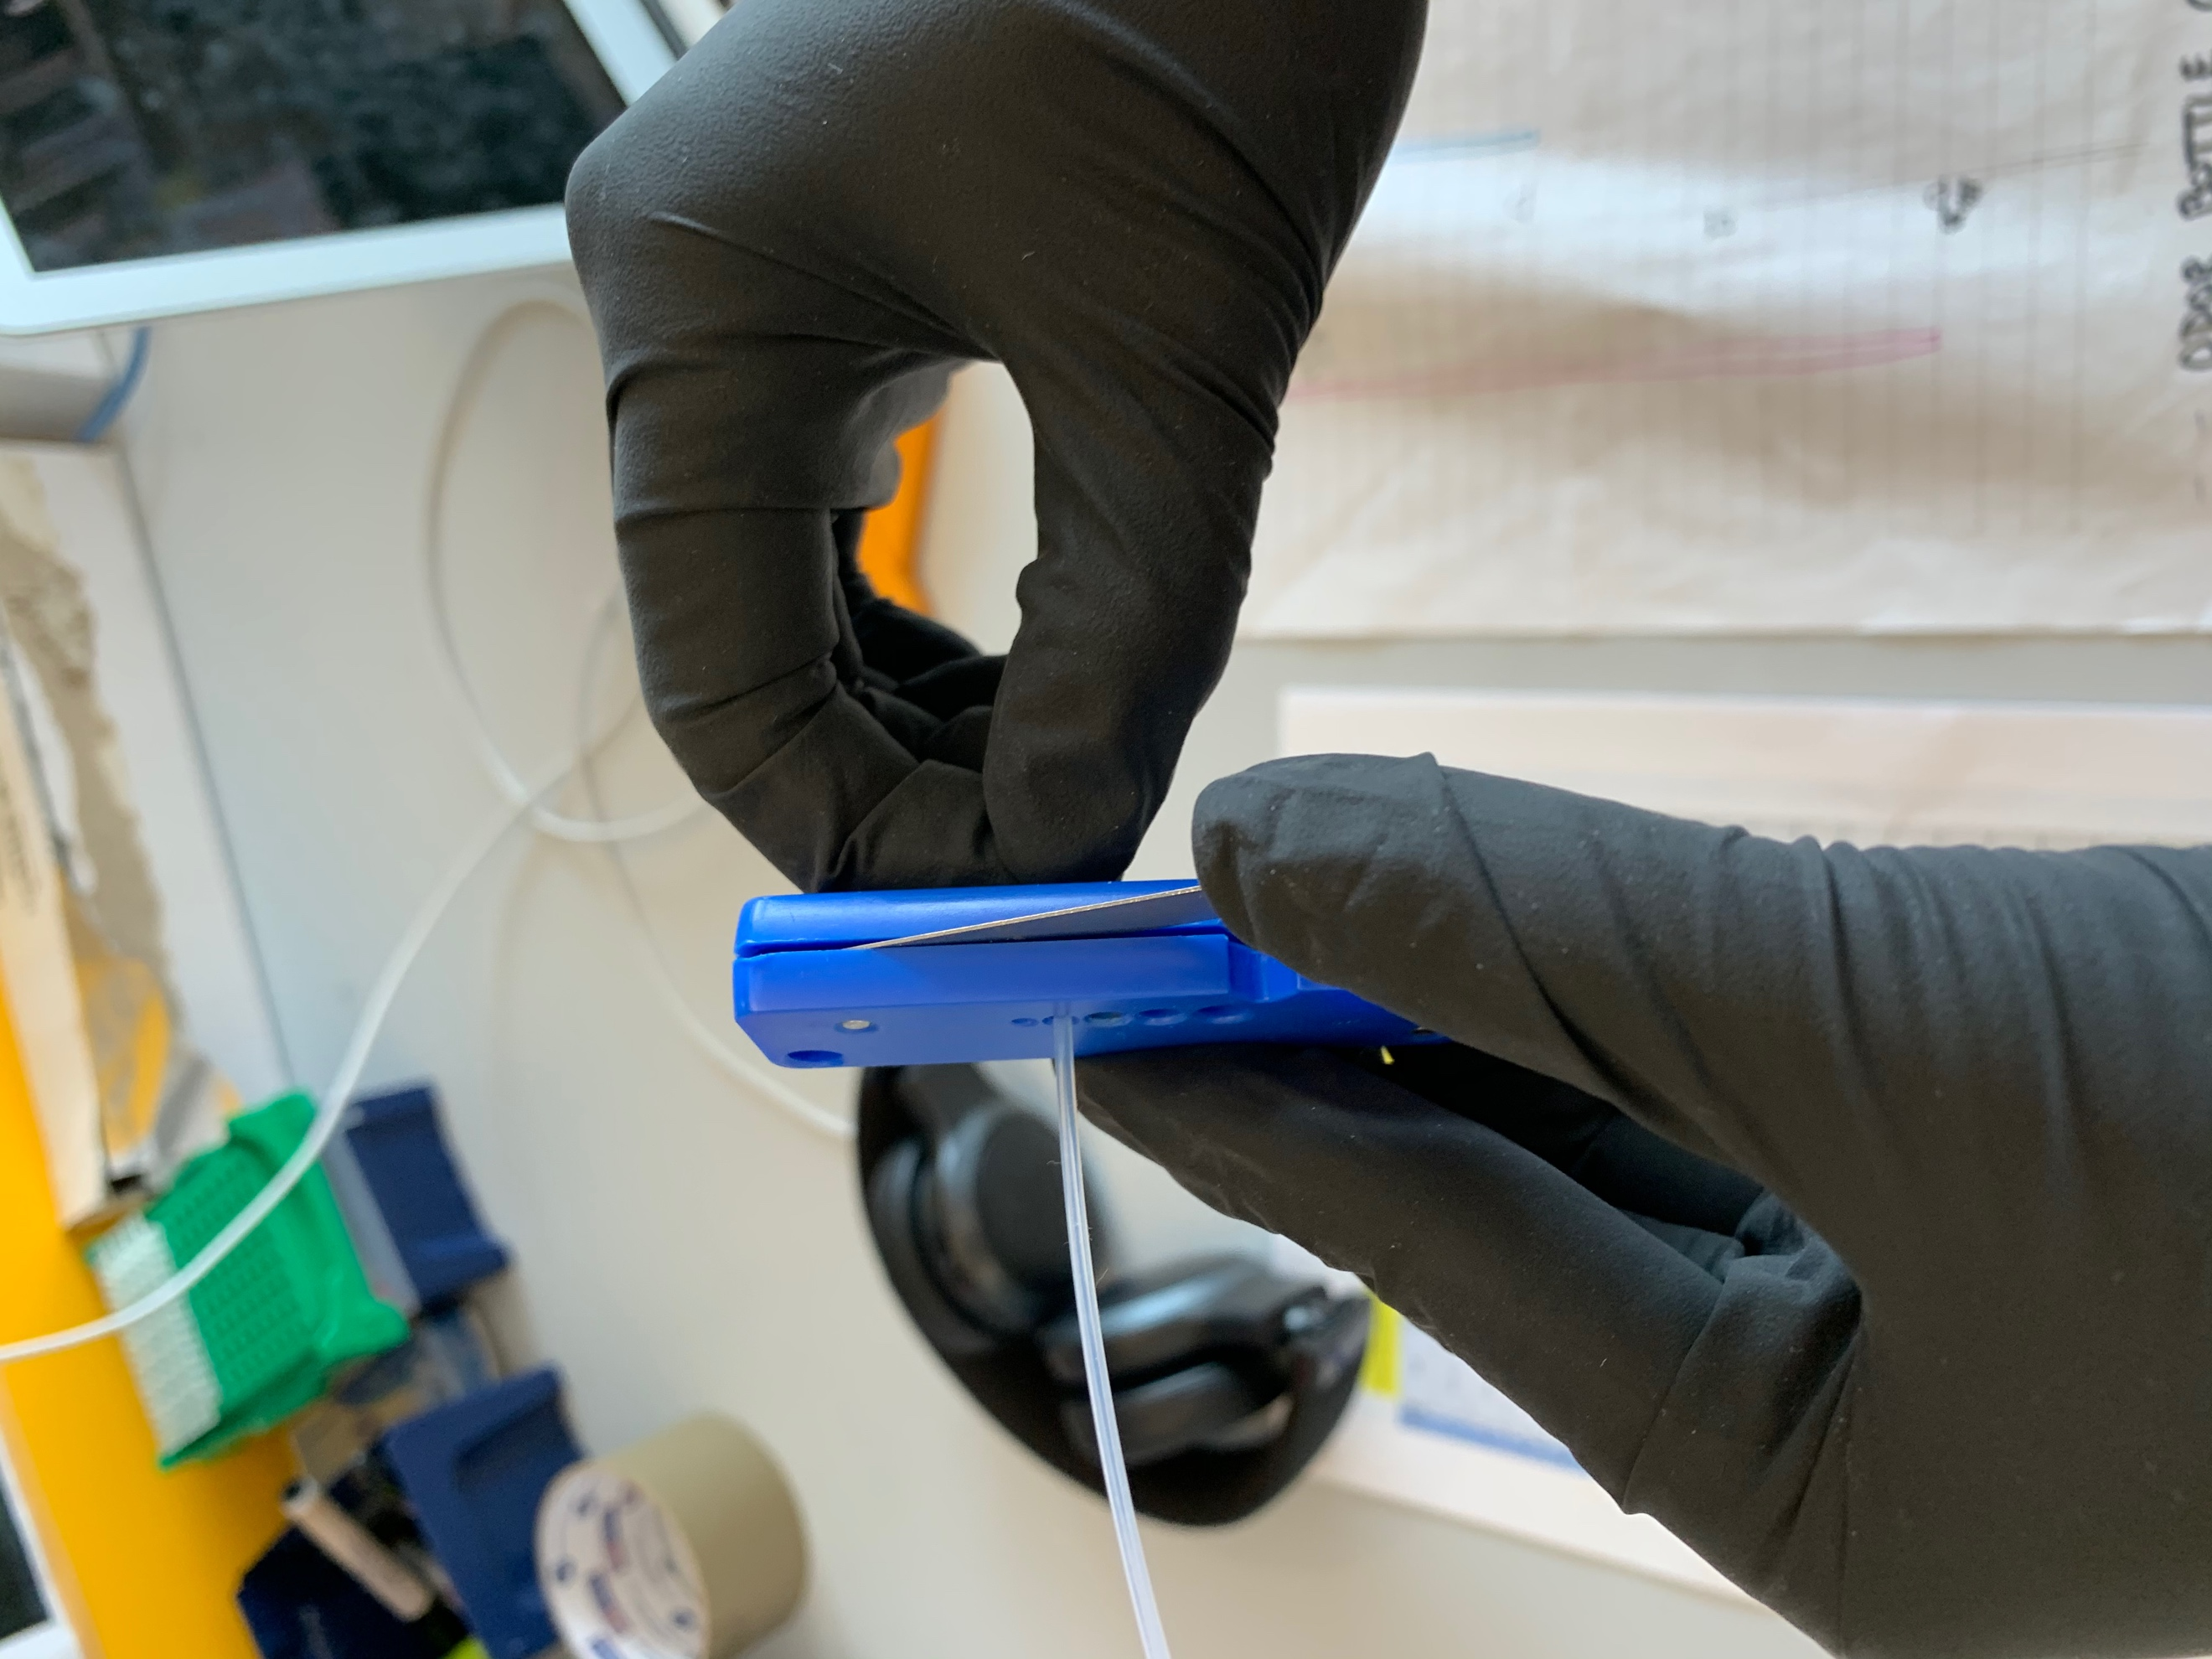

* + Do the same for the smaller “OUT” tubing, but make sure to use the tubing cutter to cut both ends of the tubing at a 90 degree angle
* Screw the plug into one of the holes of the cap

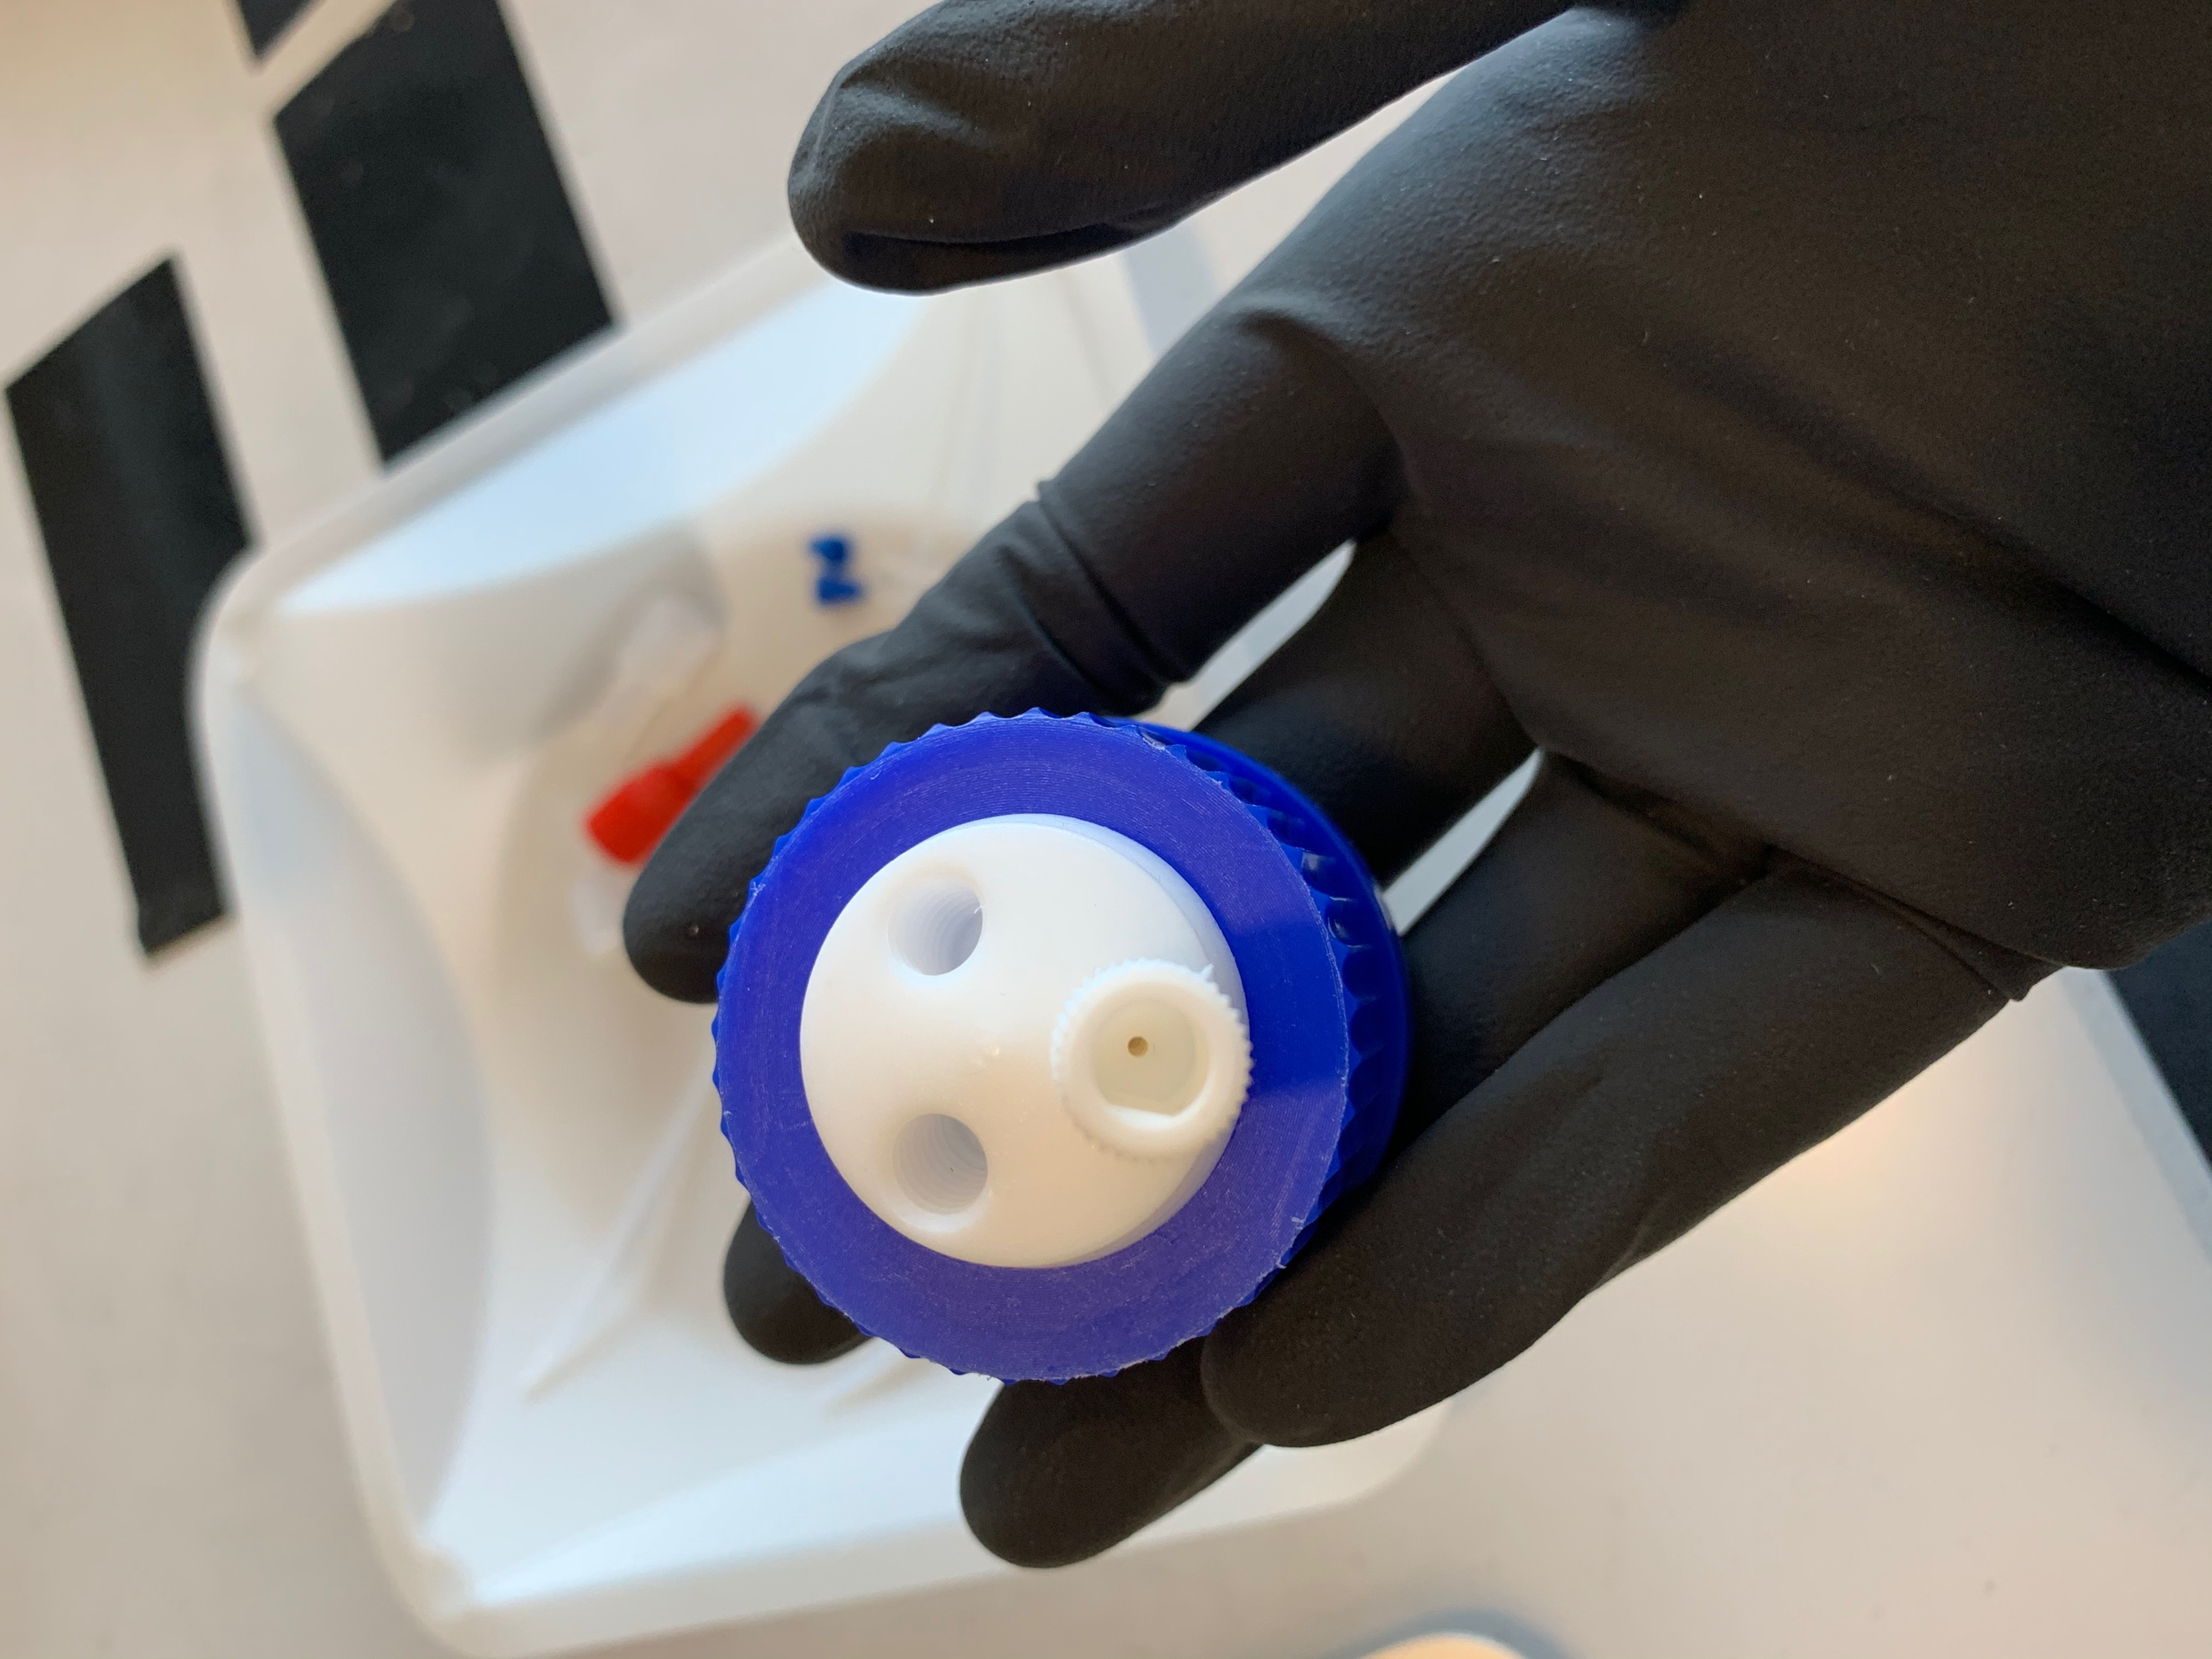

* Take the longer “IN” tubing, and place a blue ferrule on it, followed by two clear nuts, and another blue ferrule (make sure the ferrules are oriented correctly, as shown below, and that the ferrule on the end is flush with the tubing, as shown in the second photo)

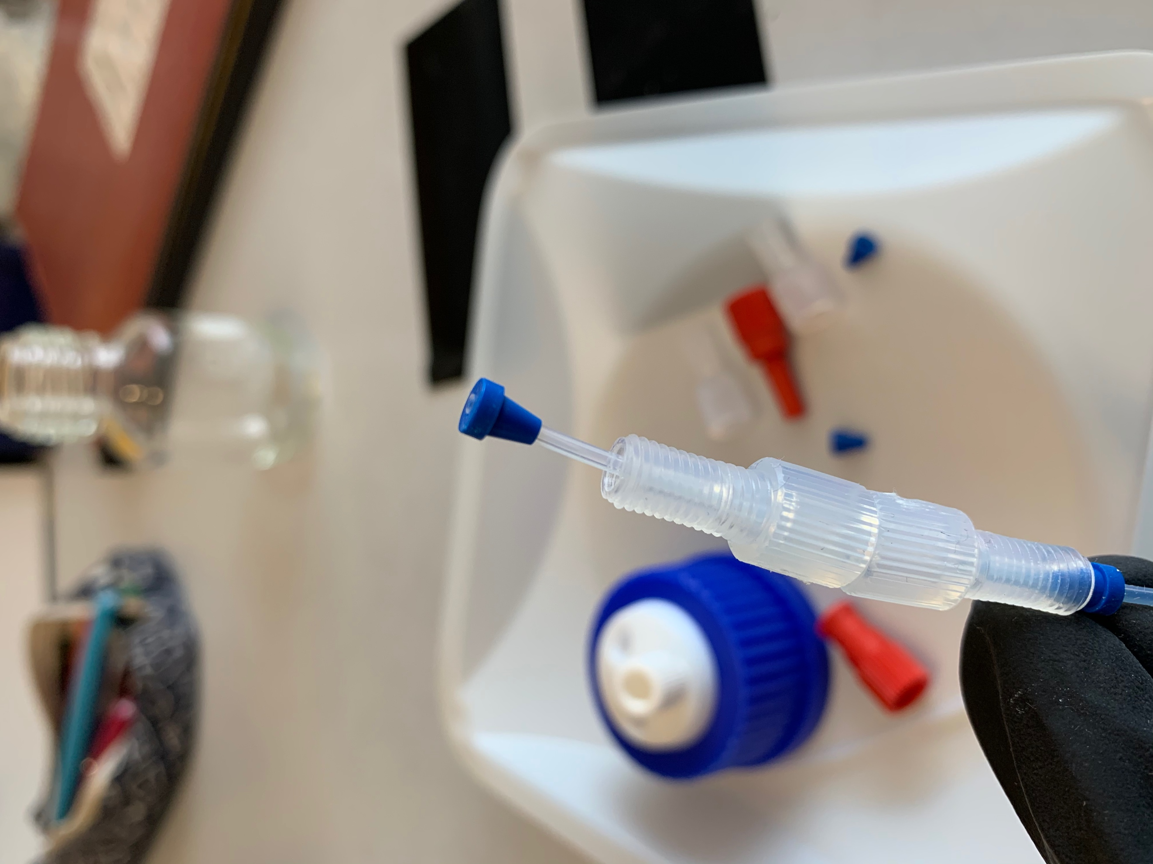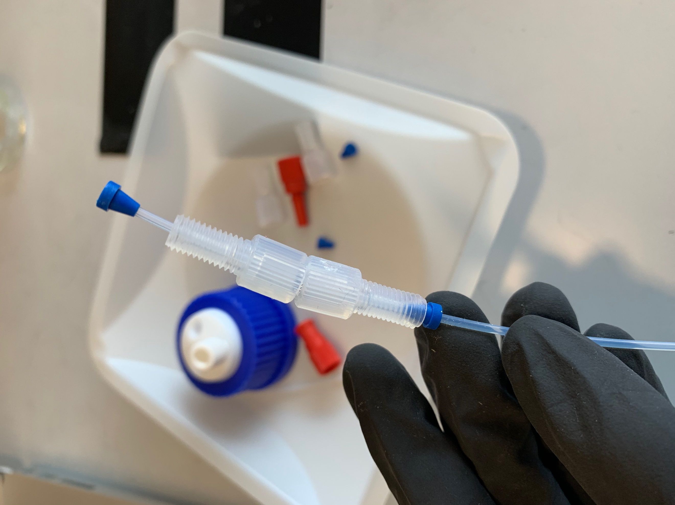

* Screw the female luer onto the nut closest to the flush ferrule, and be careful not to change the position of the ferrule so it remains flush with the tubing
* Screw the other nut into the cap to the left of the plug
* Repeat this process with the shorter tubing but with the male luer
  + IN tubing – female luer
  + OUT tubing – male luer

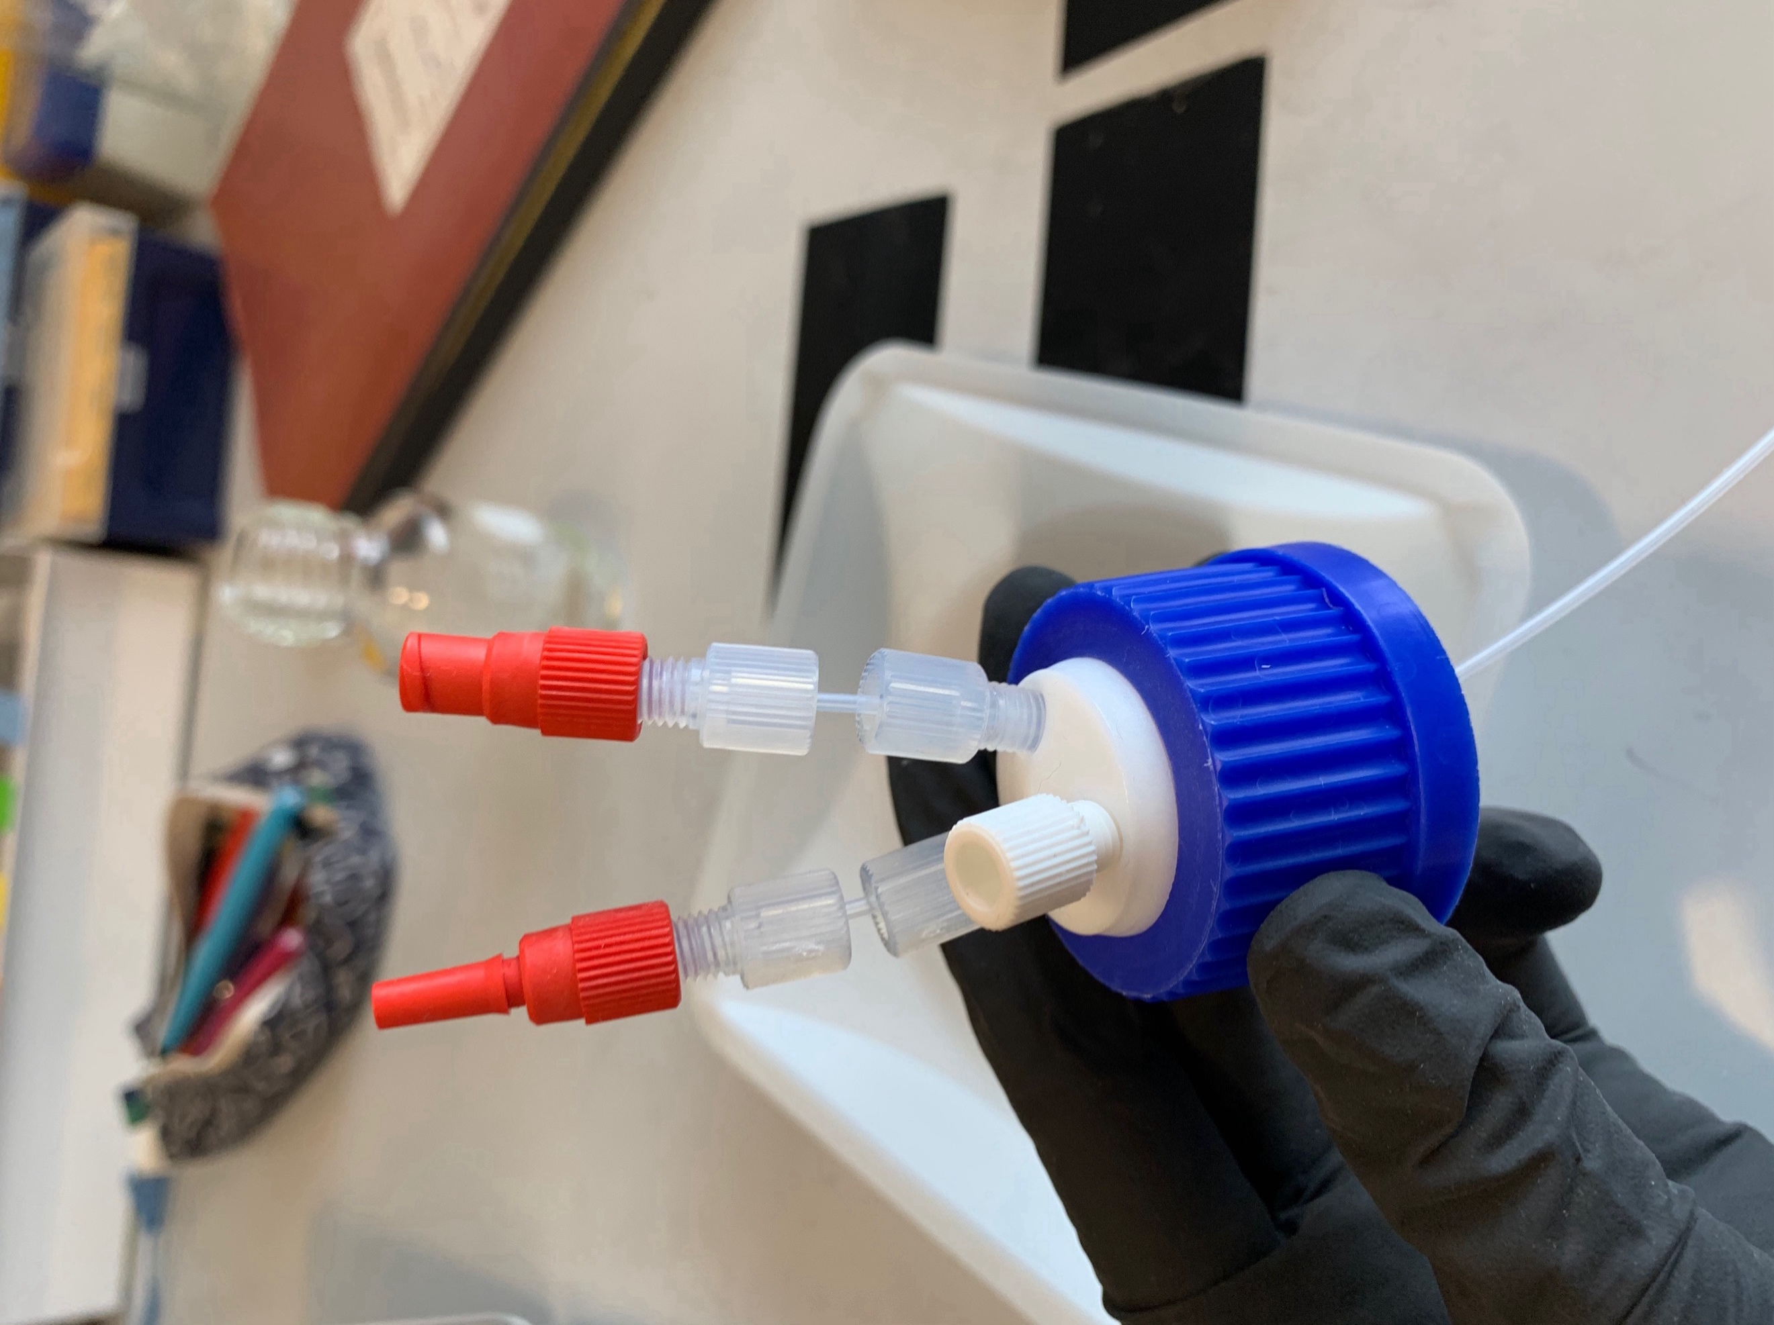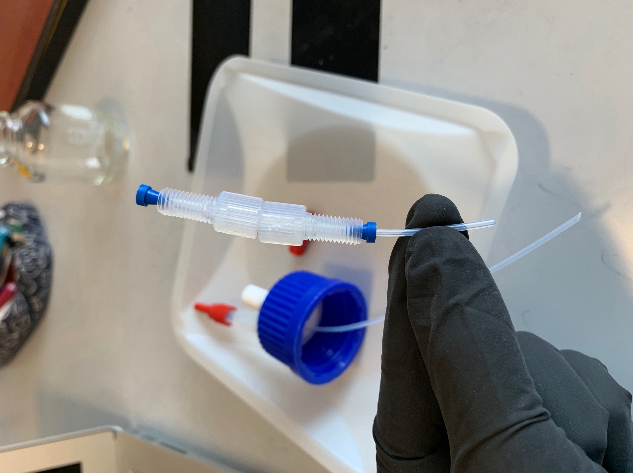

* Screw the cap onto the bottle
* Place filters onto the male and female luers to keep them clean